**Project Week 1(Deploy static website on AWS)**

**1. Create S3 Bucket.**

**Bucket name --> my-2113-website**

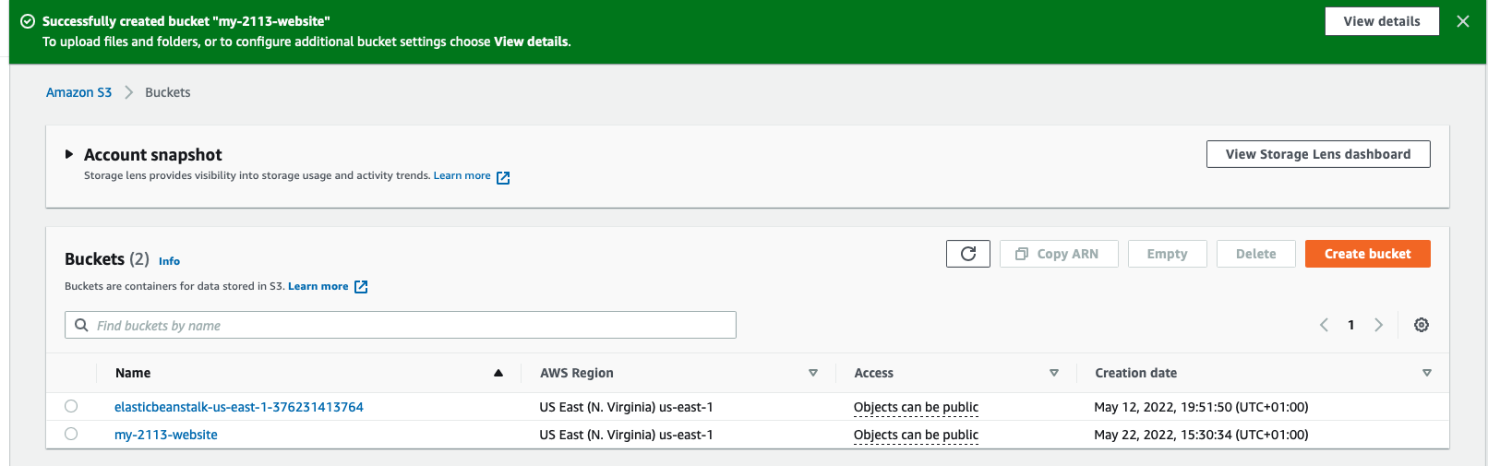

**2. Upload files to S3 Bucket**

This can be done via the aws portal or tthrough aws cli on your local machine.

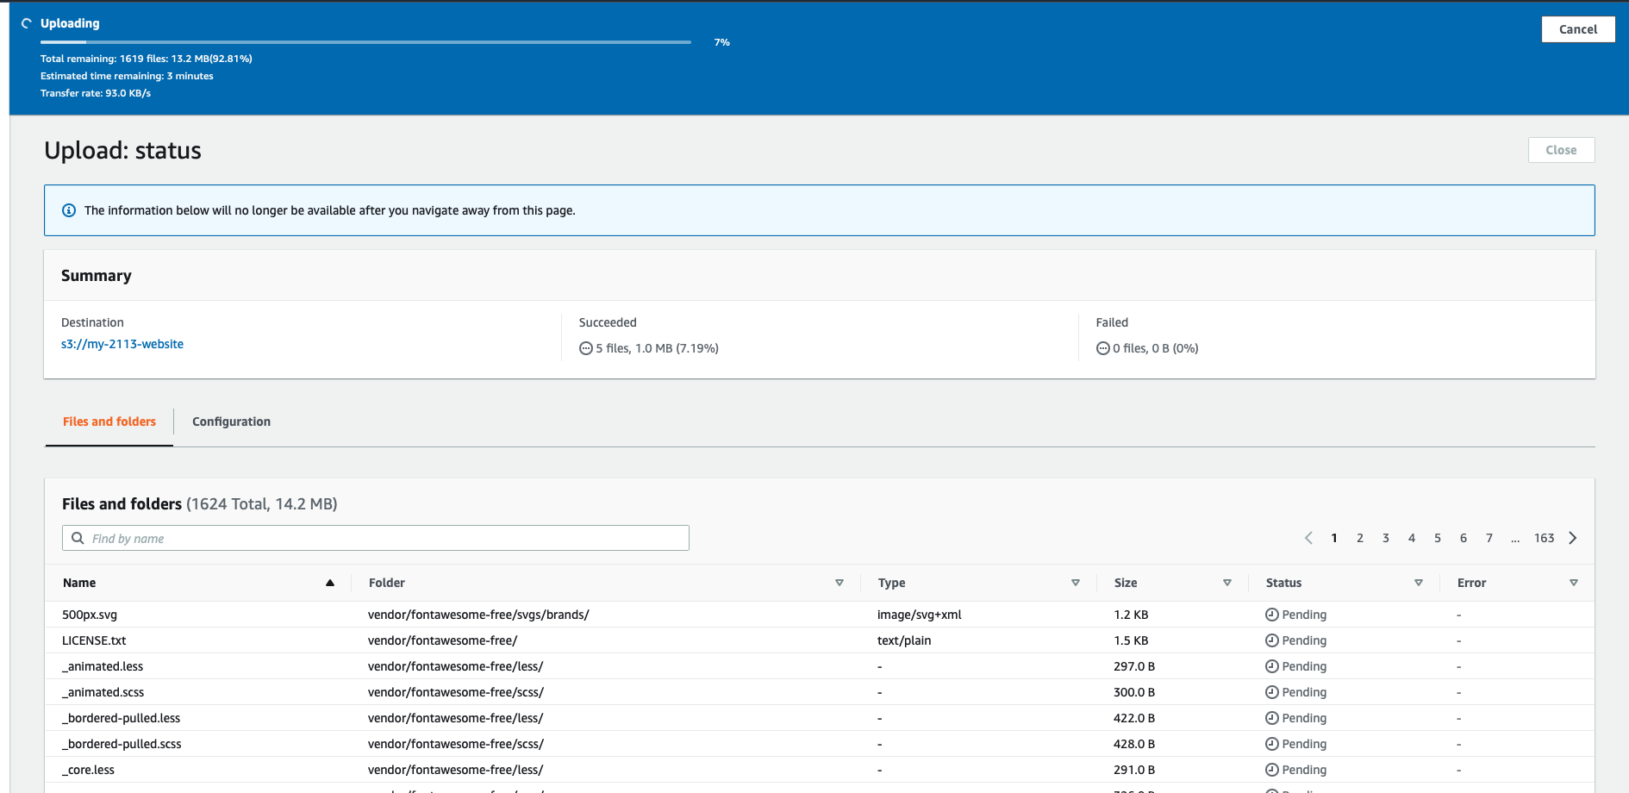

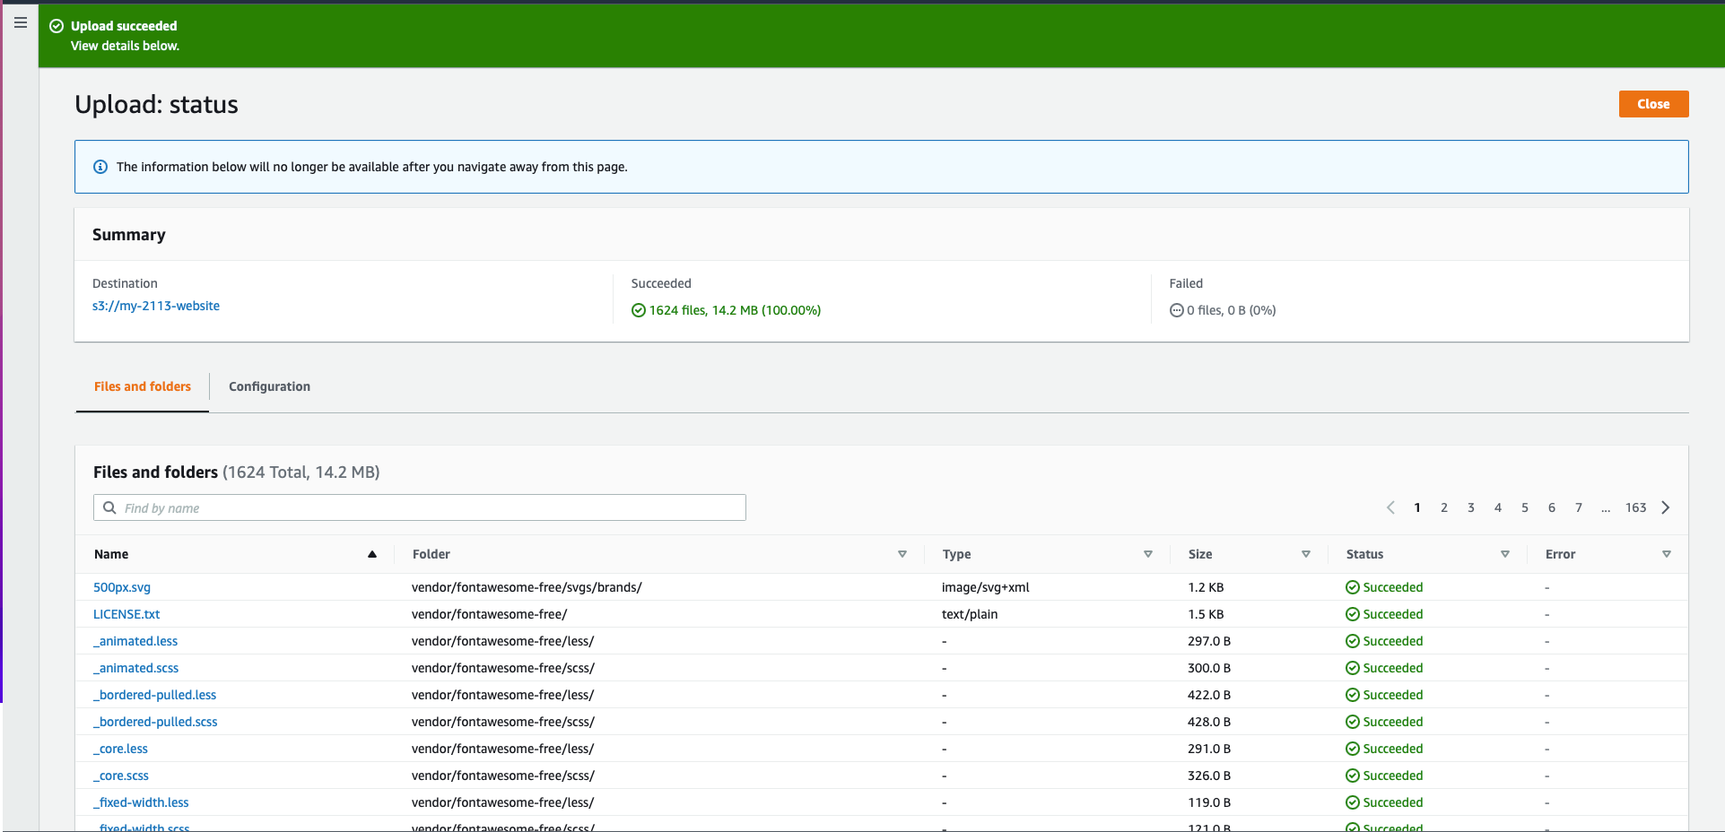

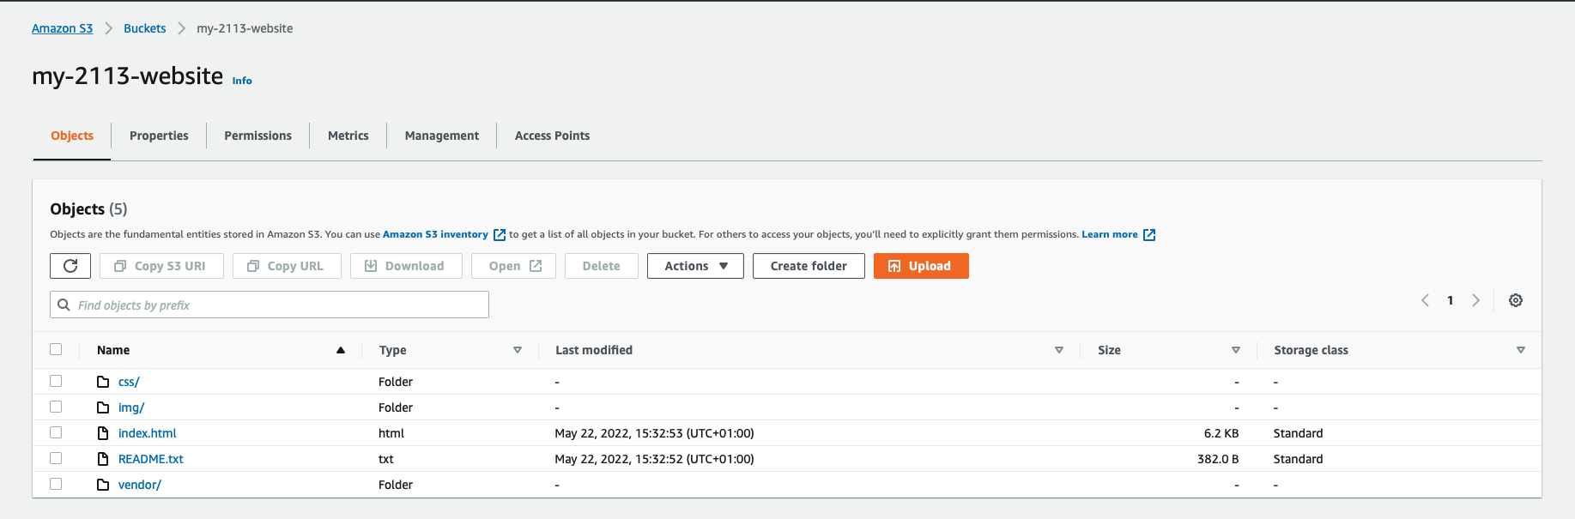

3. Secure Bucket Via IAM and configuration of S3 Bucket.

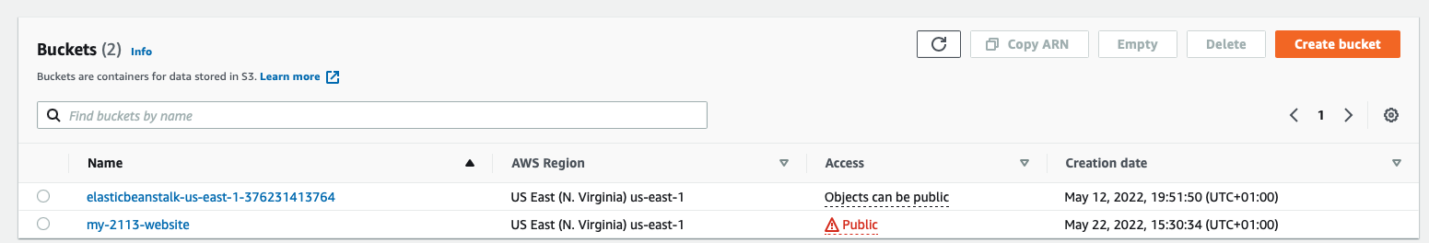

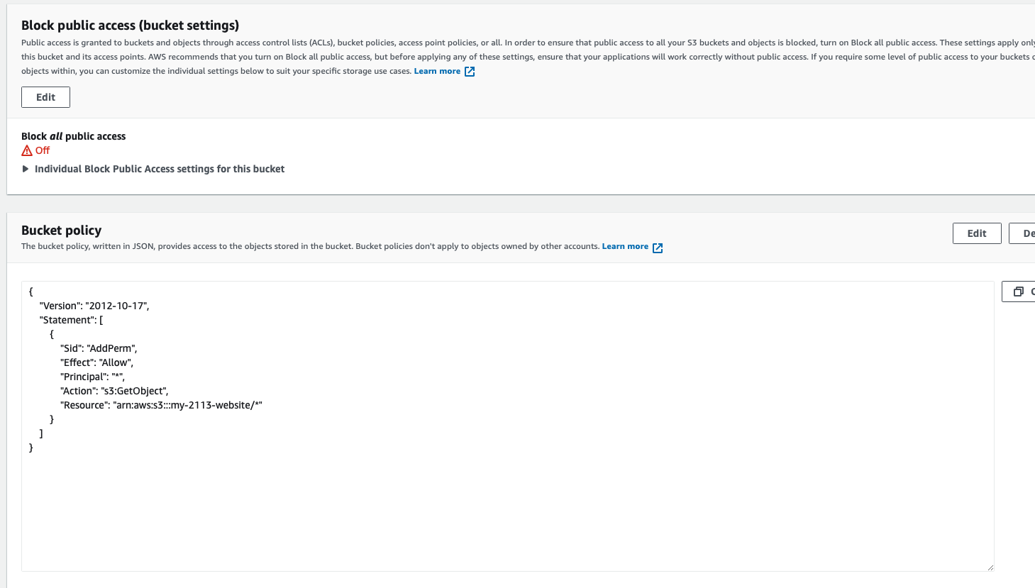

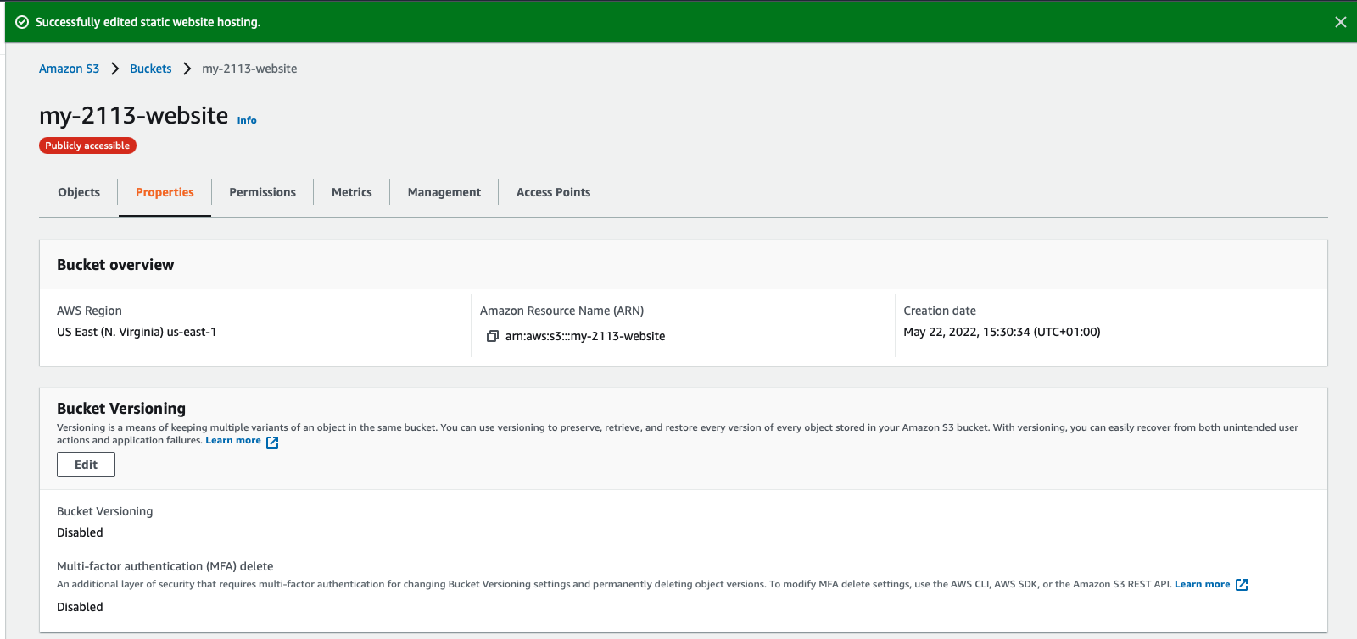

URL --> http://my-2113-website.s3-website-us-east-1.amazonaws.com

4. Create CloudFront to distrunte website.

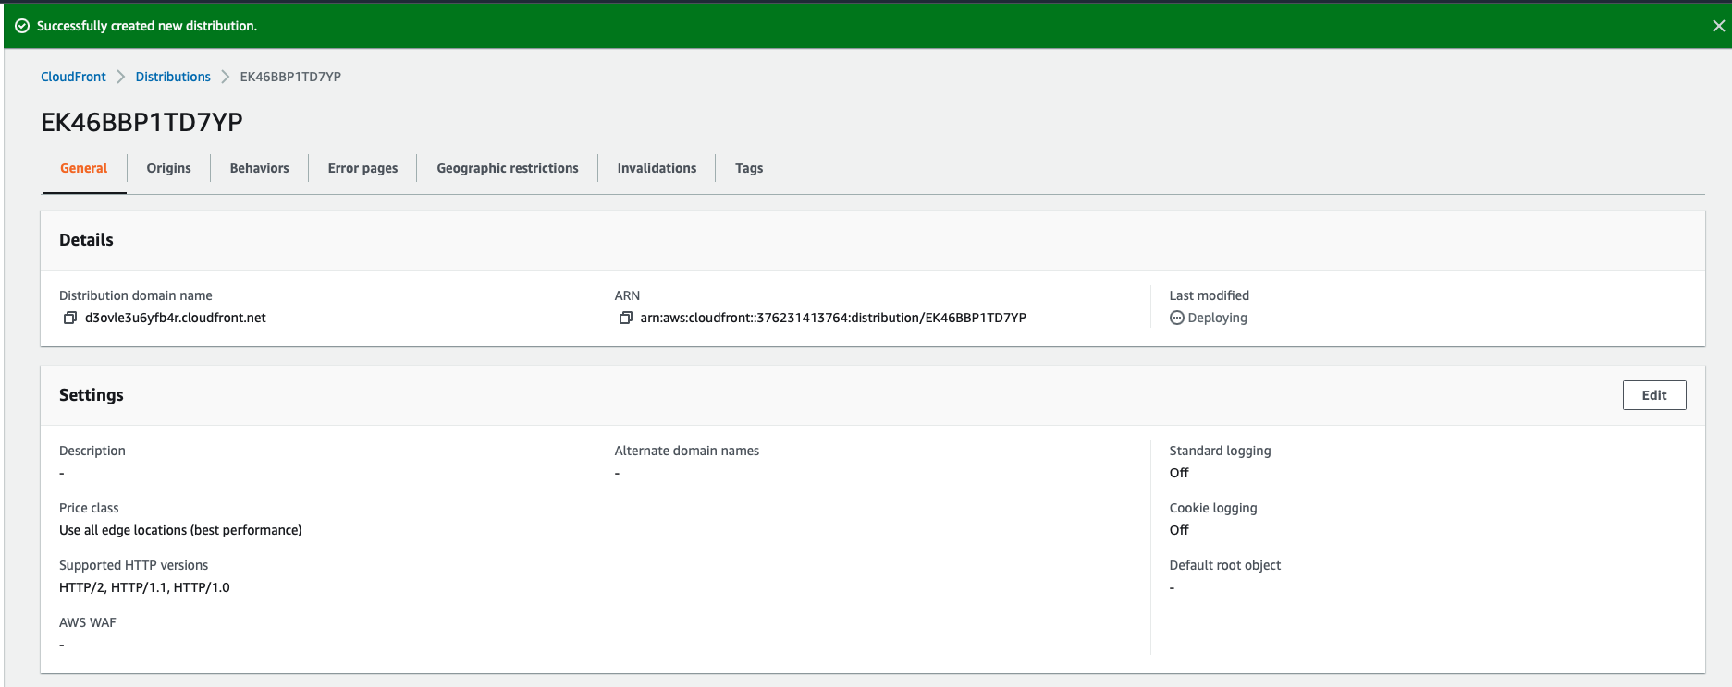

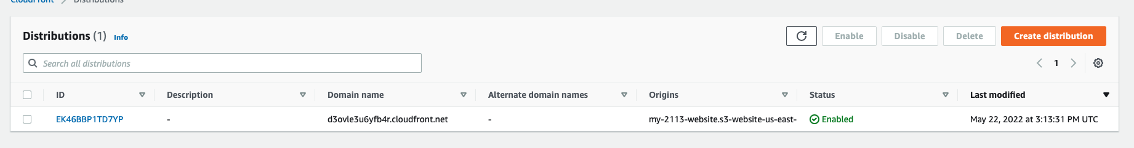

5. Viewing the webiste on different URL

https://d3ovle3u6yfb4r.cloudfront.net

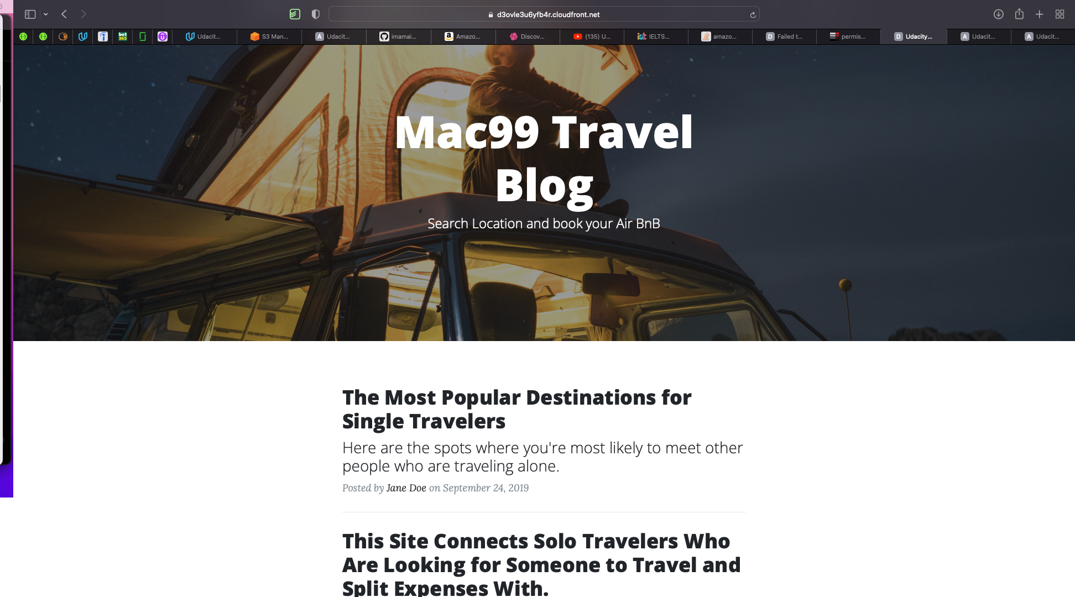

https://my-2113-website.s3.amazonaws.com/index.html

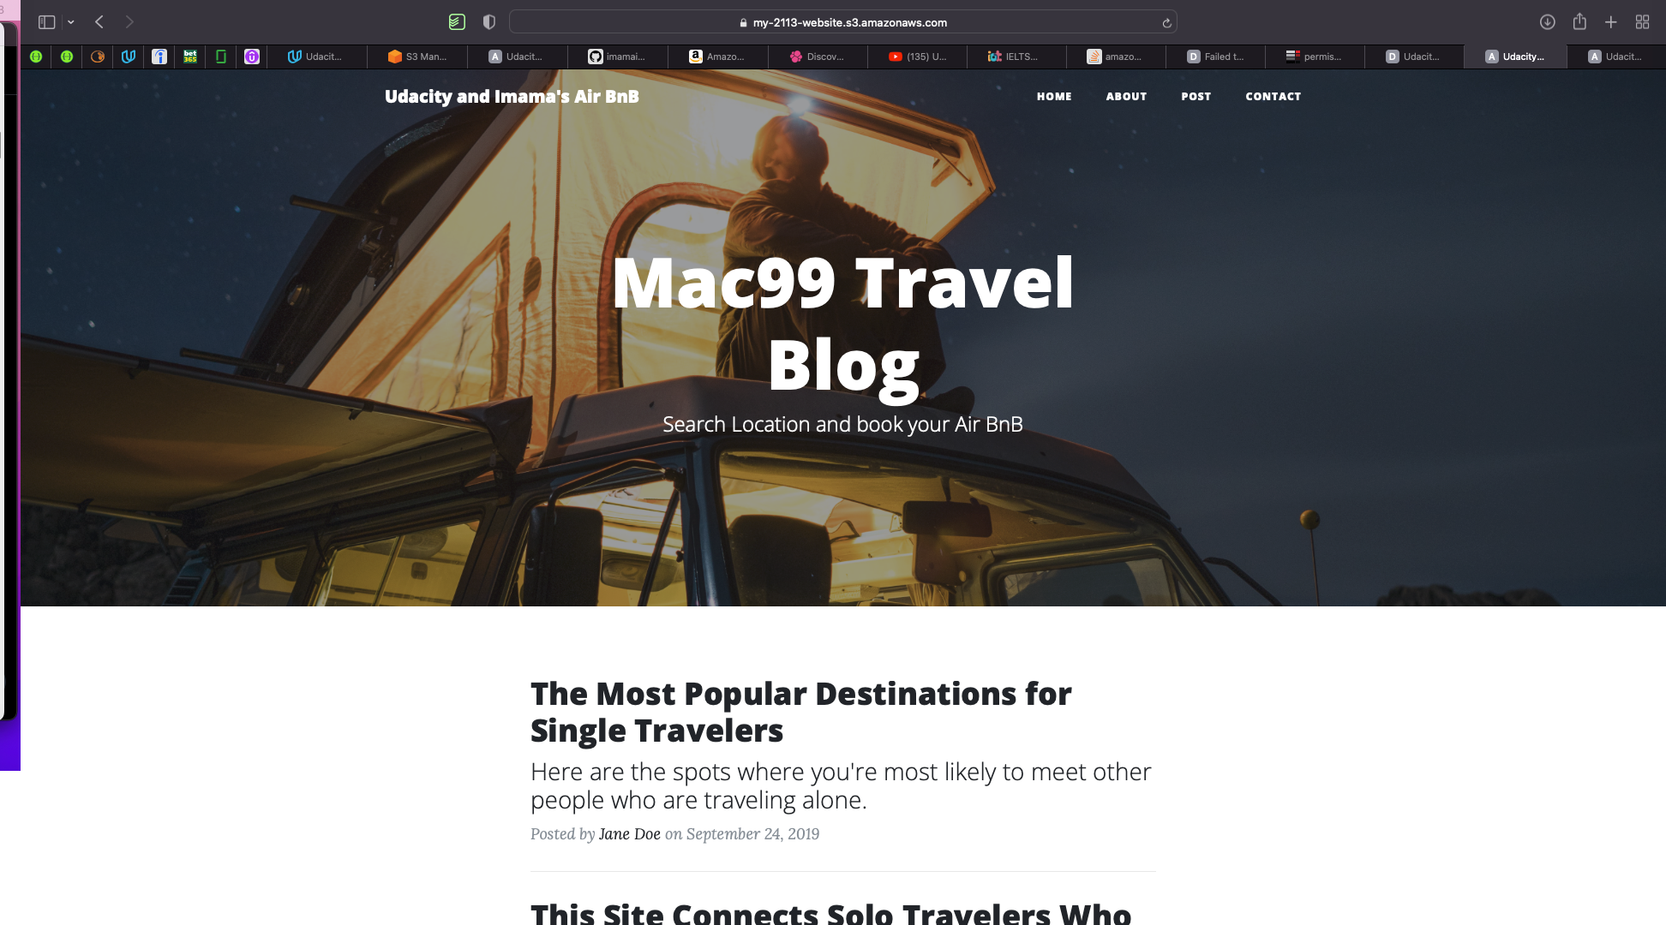

http://my-2113-website.s3-website.us-east-1.amazonaws.com/

